**The Battle of Screens vs. Nature**

**Book Z Primary Edition**

by Kawai Balancio and Kristen Gagnon

Illustrated by Malu Sanchez

Page 1 - 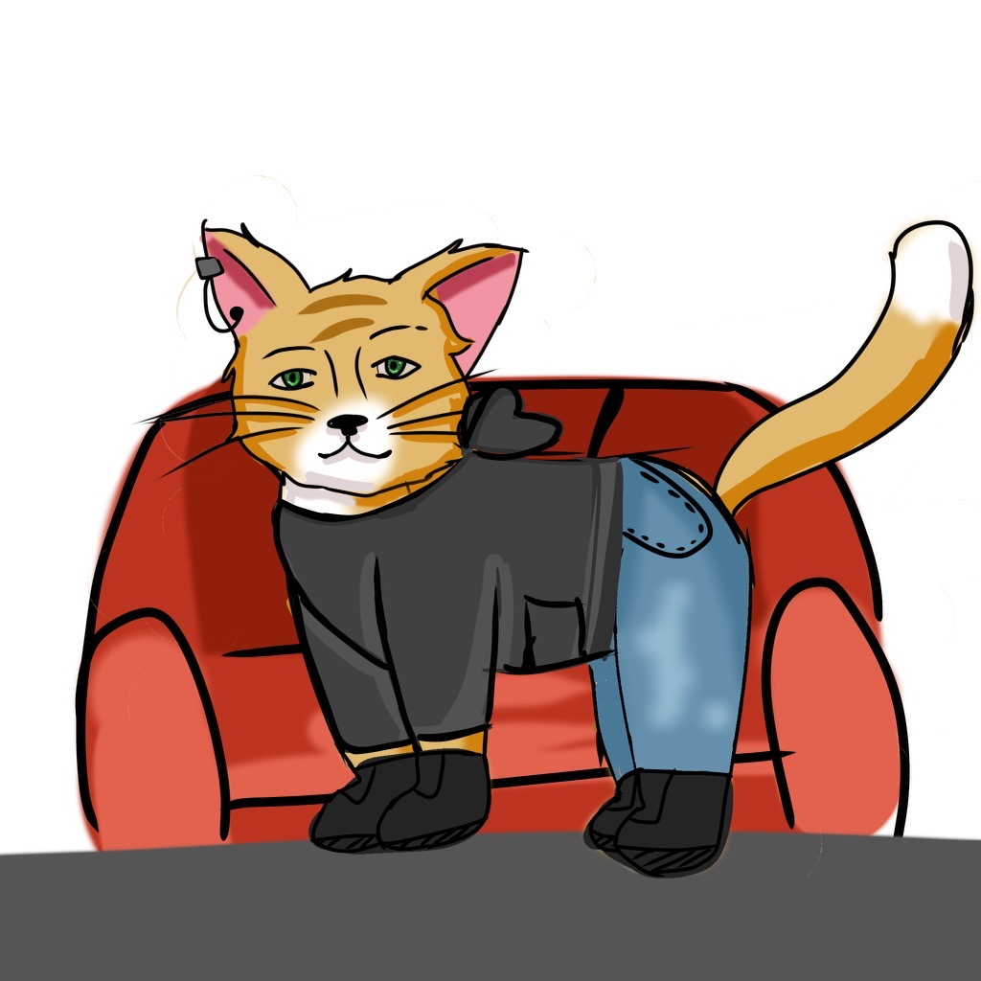

Zack was an orange, fluffy, long-haired cat who loved to watch screens.

Page 2 -



One day Zack’s mom said, “ You are on your screens too much.” She asked him to find something fun to do outside. Zack heard about a contest in Hawai’i called Find the Albino Manta Ray. If you find the rare albino manta ray and take his picture, you win one million dollars.

Page 3

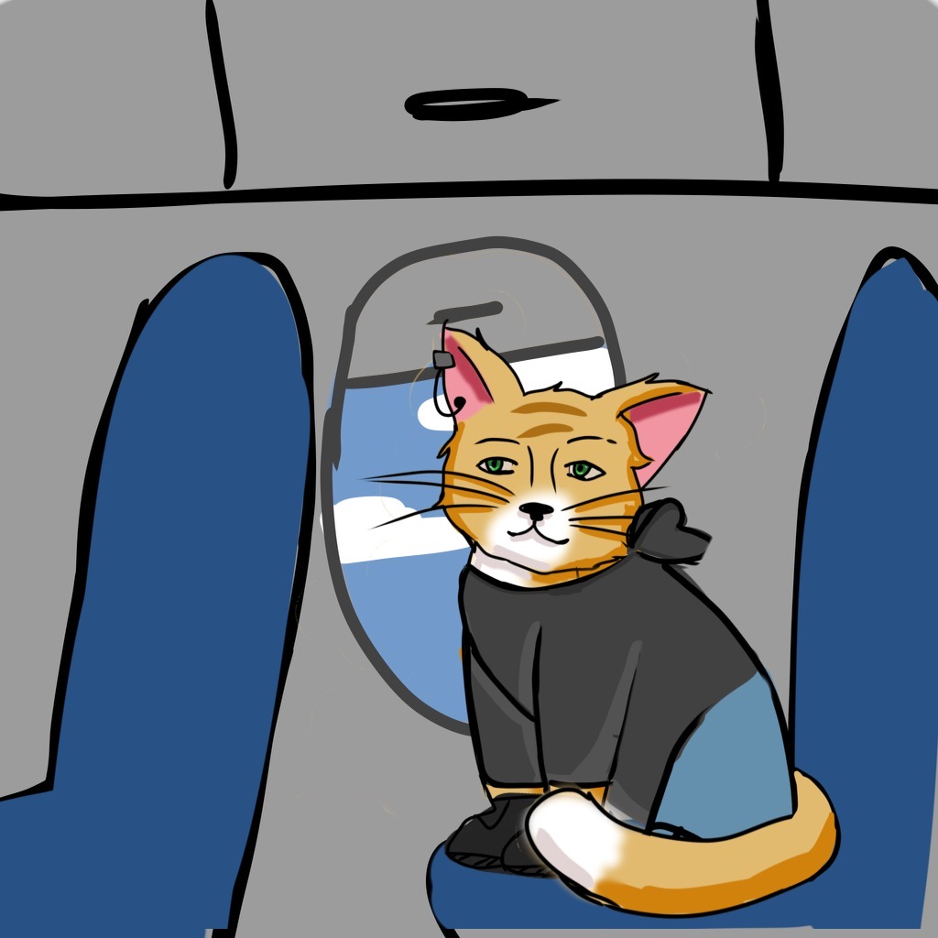

Since the adventure was in the Hawaiian Islands, Zack flew to the Big Island of Hawai’i. When he arrived, he found a keiki boat tour which took him to look for the albino manta ray. He spent days searching. Zack had so much fun that he didn’t miss his screen time.

Page 4-

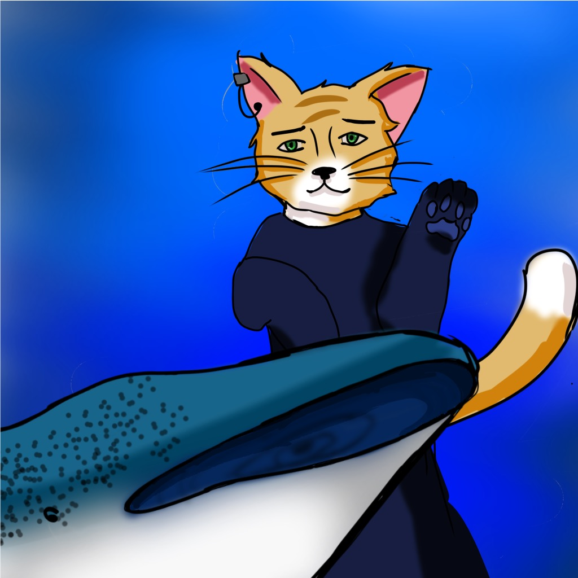

For days and days, Zack searched for the rare albino manta ray. He was determined and persistent. He would not give up.

One day when Zack was swimming next to the tour boat looking for the albino manta ray, he was surprised to see a magnificent mama whale shark. She started swimming towards Zack as if she had something to say. She needed his help. He thought he was on the search for an albino manta ray and never in his wildest dreams did he think he would be helping a mama whale shark.

Zack’s mind said, “Swim away, she is so big and scary.”

However, his heart said, “Be brave, Zack, and follow the mama whale shark! It looks like she is in trouble.”

Page 5

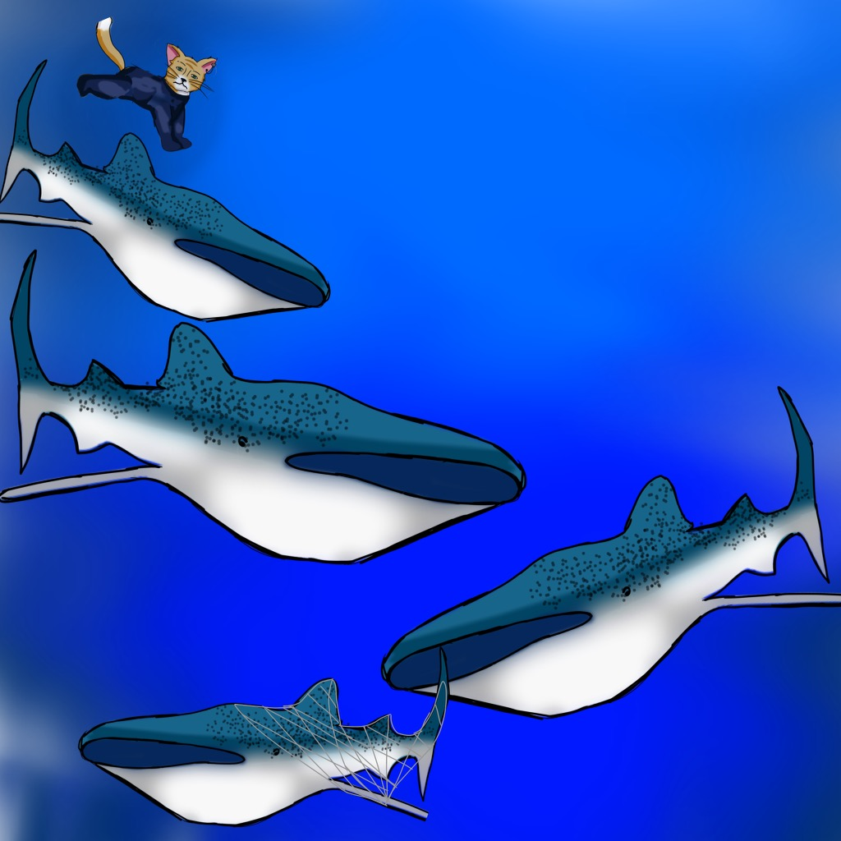

He was right! As he swam deeper, he saw her baby shark tangled in a big net! Quickly, Zack zipped down to the baby whale shark and gently untangled her. At last, the baby was free. Zack felt proud that he had helped her.

Page 6

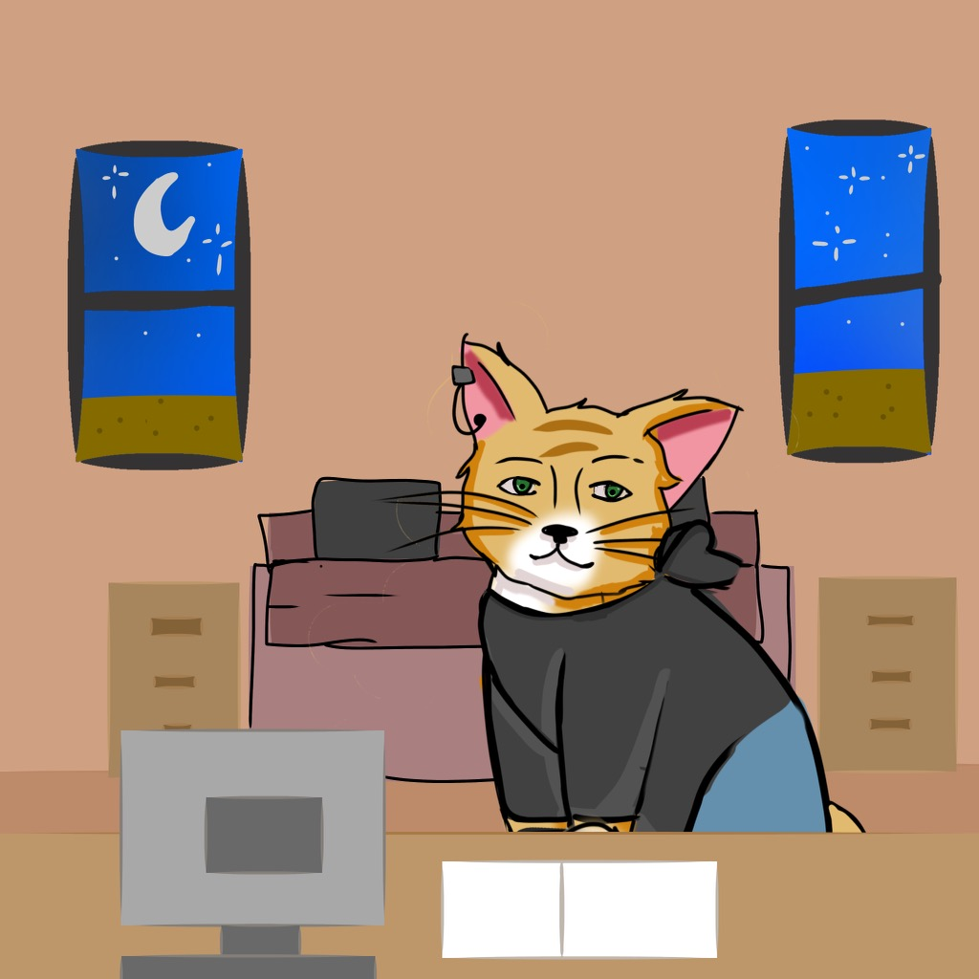

After the baby shark rescue, Zack was ready for a change. He booked himself into a cabin closer to the ocean so he could hear the calming waves of the sea. He was falling in love with Mother Nature more and more.

Still hoping to find the albino manta ray, Zack kept learning more about mantas. He learned they eat plankton. He also learned about the manta’s life cycle.

Page 7

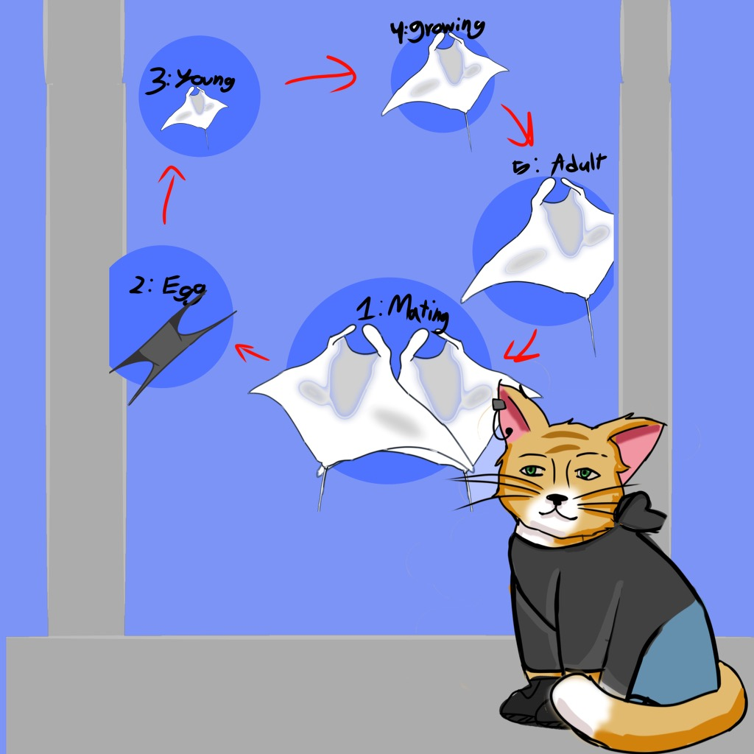

The next day, Zack zinged through a museum that exhibited sea life. His curiosity grew.

Page 8

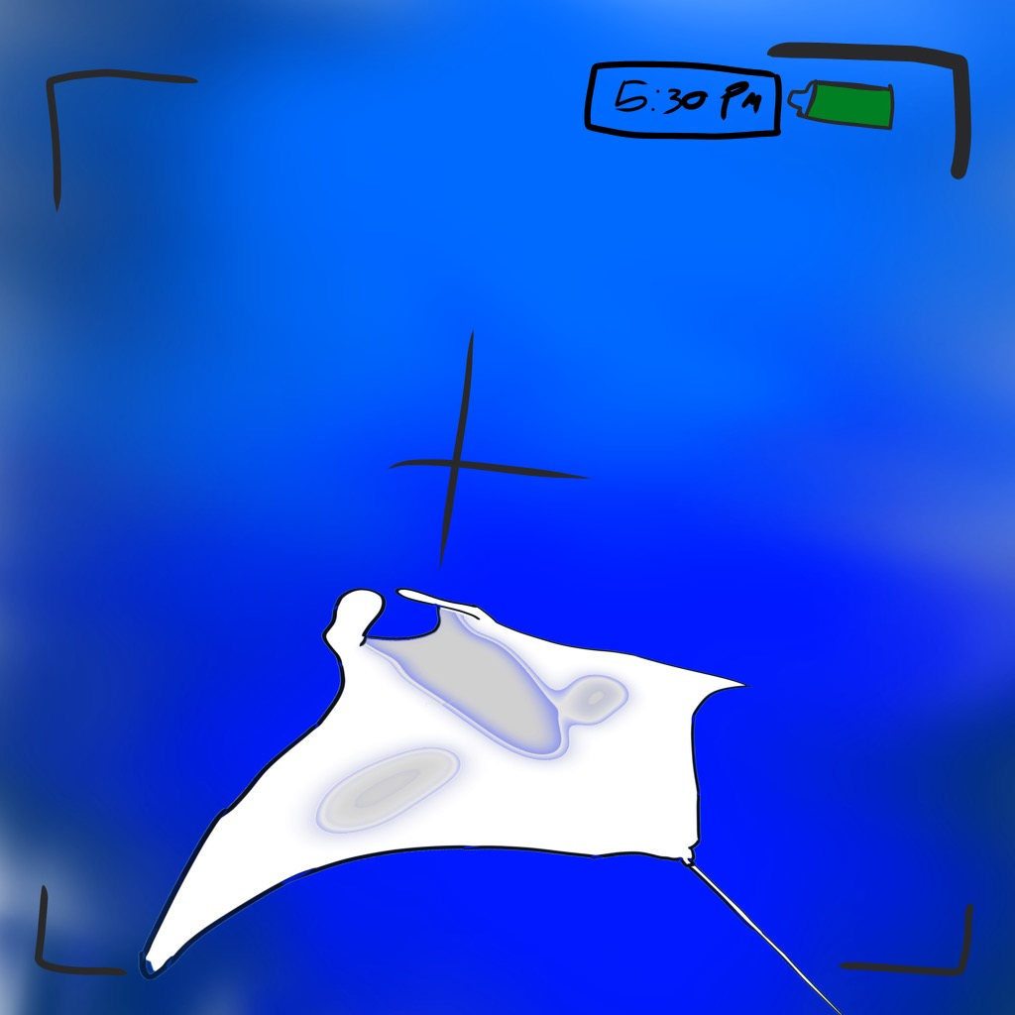

While at the museum, Zack met a kind boat captain named BZ Benda. The captain took out manta ray night tours on the Big Island.

That night, Zack went out on BZ Benda’s tour. He couldn’t believe it when he saw a big albino manta ray swimming by! He zapped a photo for the contest.

Pg 9

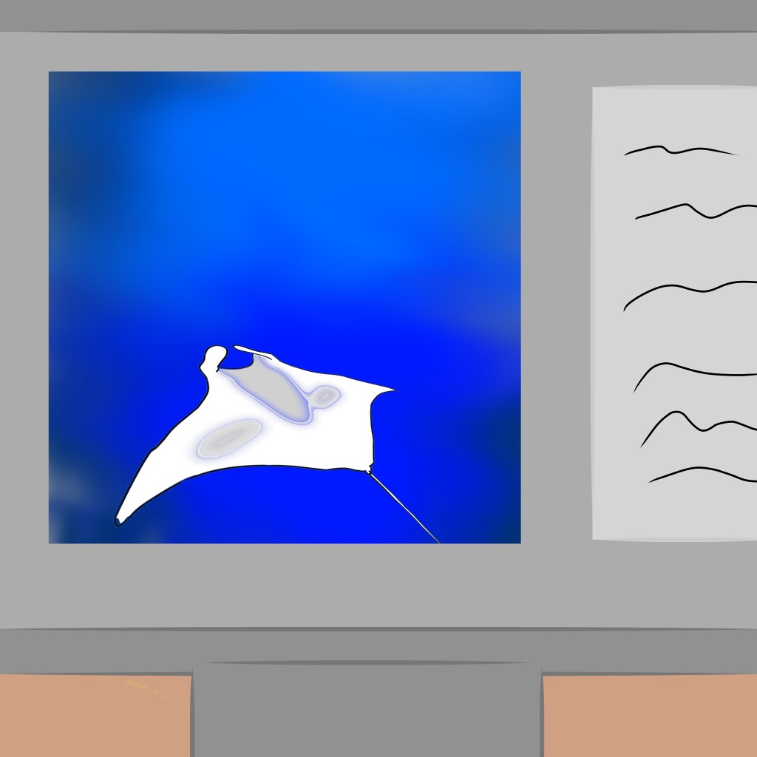

As soon as Zack got back to the cabin, he sent his picture to the contest.

The next morning Zack got a phone call. “Hello Zack, you are the first person to take a photo of the rare albino manta ray! You won the one million dollar prize!”

Page 10



Zack started jumping up and down with excitement. He was happy that he had gone on this adventure in nature instead of spending his time on screens. He had saved a baby whale shark and found the white albino manta ray.

With his winnings, Zack, opened up his very own marine hospital on the Big Island of Hawai’i. He named it, Helping the Animals of the Kai.*

**Moral: Spend more time in nature and limit your time on the screens.**

Kai - Hawaiian for “ocean”

Parent Tips: A parent is anyone in a caregiving role.

1. Our intention is to inspire a lifelong love of reading.
2. Reading time is for interaction and closeness with all your attention on your child.
3. For younger children, have them sit in your lap or close to you when reading.
4. Ask your keiki what he/she sees in the picture and write down what is said. Those sentences and words are in your child’s brain. Your child can tell the story much earlier than they can read the story. In general, children’s listening vocabulary is two years above his/her reading vocabulary. As an extension look for books written in a foreign language, it's so fun to hear what the child says is happening in the book.
5. During early childhood years, have your child draw pictures on blank paper about this book, using proper pencil grip.
6. Play Eye Spy and look for the kitty paw print in each picture.
7. Take time to talk about the words in this story and how they relate to your child’s life.
8. Be an active listener. Ask questions such as, “Have you ever wanted to go on an adventure? What animal would you like to learn more about? Was Zack brave when he rescued the baby whale shark?” Explain that being kind and helping animals fills you up with “happy juice,” which is a teacher’s term for endorphins.
9. Make a cat puppet as an art extension activity with a small lunch-size paper bag or a sock that you can Sharpie to design a cat's face. You can also use a chopstick and 3x5 card to make a stick puppet. Be sure to give the cat puppet a name that starts with a Z.
10. If your child gets wiggley, stop reading and play a game. Your child can take a walk outside or get a drink of water. Jump up and down 100 times! (Children love this!) Keiki can cross their hands over their chest, remind them not to spin just jump. Jump to math facts or a rhythm for another variation. Then, when they are ready, start reading again.
    * Neurogenesis (creating new brain cells) occurs 5 minutes after vigorously increasing your heart rate! Jumping is a beneficial and fun activity for learning. Rebounders and trampolines are great, too. Kids have always known this, they love trampolines and go for the fun factor.
11. Vocabulary Words: Explain these words with synonyms. Connect the word to your child’s life experiences. Keiki learn language best by interacting in small groups and talking. We have an intention of connecting with others for social interaction when we teach language.
12. Before you begin a lesson, take 5 minutes to complete these actions:
    * **Water:** Sip water at the beginning and throughout the lesson. Encourage drinking water when you see your child distracted or making mistakes. Staying hydrated for better thinking is a major component of learning.
    * **Breathing:** Spread your fingers and gently massage under the collarbone with your middle finger and thumb on either side. Put your other hand on your belly button. This movement encourages circulation and better thinking bringing more oxygen to your brain! Breathe deeply as you massage these points.
    * **Cross-Brain Connection:** Engage the left and right hemispheres of the brain to make you a more whole-brain learner. SLOWLY WATCH your hands as they clap in front of your face. Track your right hand to the left knee, clap in the center, and then clap the left hand to the right knee. Repeat while crossing the body to the opposite knee. Do this do a rhythm or a song, two of our favorites are *This Land is Your Land* or Bob Dylan’s *Knic-Knack Paddy Whack* from the *album, Every Child Deserves a Lifetime.*
    * **Calm Down:**  Sitting down, cross your left ankle over your right ankle. Then cross your right arm over the left at your wrists, clasp the palms together, and pull the hands to the chest. Then sit up straight, place the tongue on the roof of your mouth, relax your shoulders, put your chin down a little, and close your eyes. Take deep 4-part breaths. Then slowly inhale for 4 seconds, hold for 4 seconds, exhale for 4 seconds, and hold for 4 seconds repeat. You can also lie down and do this calming breath work position.
    * This four-step routine is powerful for anyone at any age when learning! Watch this 2-minute video with Mrs. G for a quick demonstration. <https://www.youtube.com/watch?v=iVEL9ENxa_0>

(We, as educators, still do these movements daily. We have received comments from former 8-year-old students, who are now in their forties, and still do these movements because they are so powerful. At a party, three former students in their late twenties told Rex they still used these movements. One of the partygoers was Miss Hawai’i.)

1. This book teaches the sound of the letter Z. Practice pointing it out in the story and the sound the letter Z makes. We say, “It tickles my tongue when I say ZZZZZZ.” Phonics: The sound for z is a sound students can hold for a long time.

Make the sound of a bumblebee - this will help practice the sound of Z.

1. For enrichment, you can point out that the ‘s’ and ‘ex’ make the z sound too.

* Screens
* His
* Examine
* exhibited

1. Act out the scene, ask them to act it out too. Act like a baby whale caught in a net and then act out getting free.
2. What do they like about screens? What do they like about being outside? What do they like about being with friends? When have they been around animals?
3. Be creative and interested in your child’s thinking. Where would you like to travel to see a wild animal? Do you want to see a sea animal in the wild?
4. If your child gets wiggley, stop reading, and play a game. Your child can take a walk outside or get a drink of water. Jump up and down 100 times! (Children love this!) Keiki can cross their hands over their chest, remind them not to spin just jump. Jump to math facts or a rhythm for another variation. Then, when they are ready, start reading again.
5. Neurogenesis (creating new brain cells) occurs 5 minutes after vigorously increasing your heart rate! Jumping is a beneficial and fun activity for learning. Rebounders and trampolines are great, too. Kids have always known this, they love trampolines and go for the fun factor.
6. Take time to explain vocabulary- we use synonyms.
   * Albino- no color/pigment
   * Contest- competition
   * Million- a big number
   * Adventure- a fun outing
   * Keiki- child/children
   * Tour- trip
   * Manta ray- a big and harmless sea animal
   * Determined- do not give up
   * Persistent- you want to keep going
   * Tangled- caught
   * Plankton- a small algae food
   * Life cycle- the stages from birth to adult
   * Exhibit- a show
   * Examined- to look at
   * Curiosity- interested in
   * Entered- to go in

8. Spelling Rules: **Z, NEVER S,** makes the /z/ sound at the beginning of a base word (*zoo, zero)*

**S** makes the /Z/ sound. For example: is, was, scissors. The **S** makes the /z/ sound sometimes, but never when it is the first letter of the word.

9. Homophones:

“ See more of the Sea.”

“ You won the one million dollars.”

10. Parts of Speech:

Intonation - words that express feelings

Zapped

Zinged

11. Latin and Greek Roots:

Zo - Greek: Animal

12. Sky write the letter Z. Use both hands to make the motions big and small one at a time and together. This should be fun!