**Book Z:** The Battle of Screens vs. Nature

by Kawai

Page 1 - 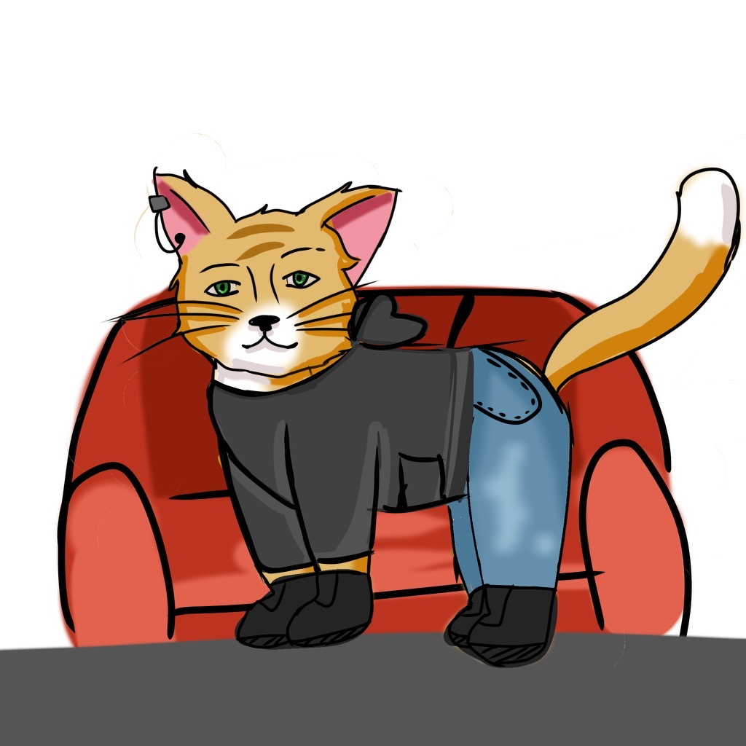

Zack loved to play video games. He was a lazy bum. He was an orange, fluffy, long-haired cat. who wore a black hoodie, one earring in his left ear, and denim jeans. He wore black Converse shoes. He liked to be bare-pawed unless he went outside (which he didn’t do often).

Being an adventurer had always interested him, but, unfortunately, he ended up on his screen most of the time. His screen time zapped all his energy and made his eyes gloss over. The screen hypnotized him! It took his mom calling him several times before he would respond. He hadn’t stepped outside of his house in months. Sometimes, he would even forget to eat!

Page 2 - (add to this illustration of Zack’s buggie glossed eyes- swirls hypnotized)



One day his mom came in and scolded him for being a gamer because he couldn’t unplug from the screen. So his mom intervened, and then he was full of rage.

She reasoned with him, “Zack you must find something else to do or else I will take away your video games for a whole year!” Zack’s mom was ok with him playing games a few hours a week but it seemed to be an addiction and take over all his life.

Zack thought and thought, “Oh man, I don’t want to get all my video games taken away.” Then, after a lot of brainstorming, he asked, “Can I use my computer to find some kind of adventure?”

Mom agreed, “Sure, Zack, that's a good idea.”

Zack went online and typed in the word “adventurous” into the search bar. He scrolled through the screen for hours. He finally came across an idea that inspired passion in his heart.

He jumped out of his chair and screamed, “Mom, I found the perfect adventure!” The screen read, *Find the Missing Albino Manta Ray. Be the winner! Submit your photograph and claim the Million-dollar Prize*.

His mom came running upstairs, looked at his screen, and saw an albino manta ray on it.

“Well, this works because the Albino Manta Adventure starts next week on the keiki research boat! Seeing an albino manta isn’t possible in any zoo’s aquarium!”

Page 3

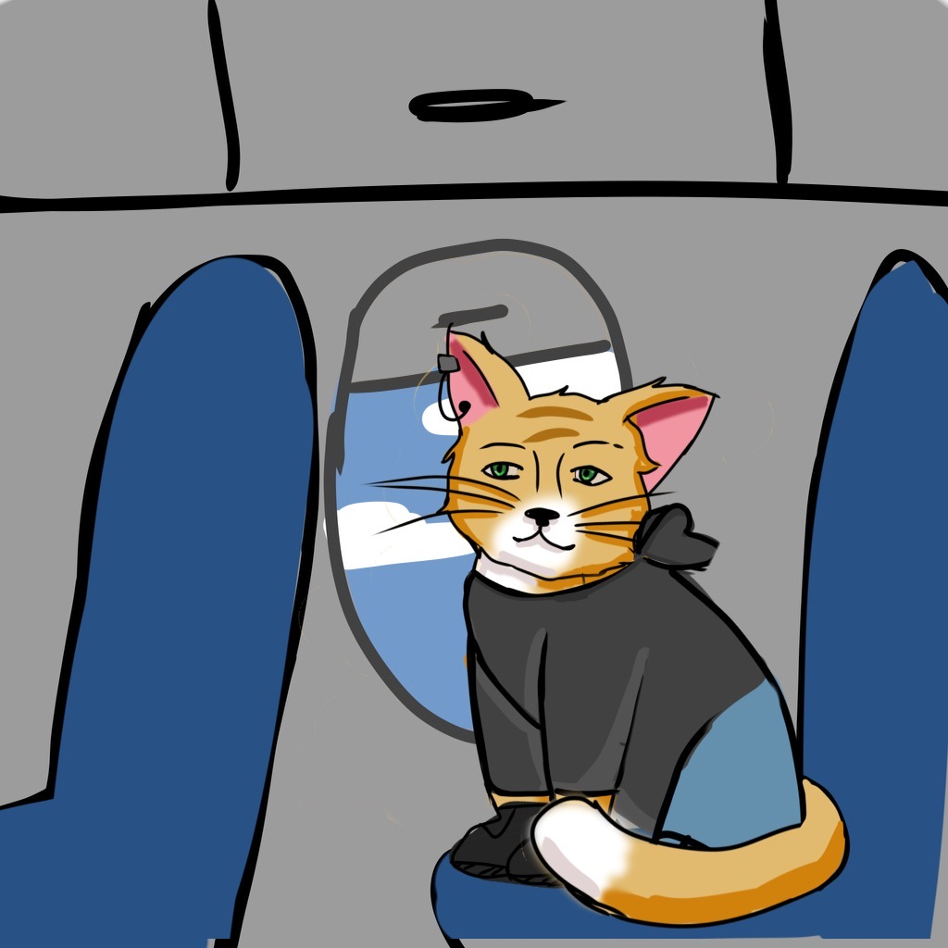

Since the adventure was in the Hawaiian Islands, Zack flew from his home in Florida to the Big Island of Hawai’i. He checked into his hotel room at the Nai’a Wai. Then, he found the keiki boat tour, Honu Kai Tour Company, that was searching for the missing albino manta ray, which frequently swam near the buoys. Days went by. Zack joined several tours to find the missing manta ray. During all these tours, he was having so much fun that he didn’t even miss playing his video games! Day after day, he’d explore different buoys as he searched for the albino manta.

Zack saw different marks on the abdomens of various common manta rays. He learned these markings were used to identify each manta ray. After a few days, he started to memorize the names of the manta rays that he saw: Amanda-Ray, Lani-Ray, Queeny-Ray, Alohi-Ray, and Big Bertha-Ray.

Page 4-

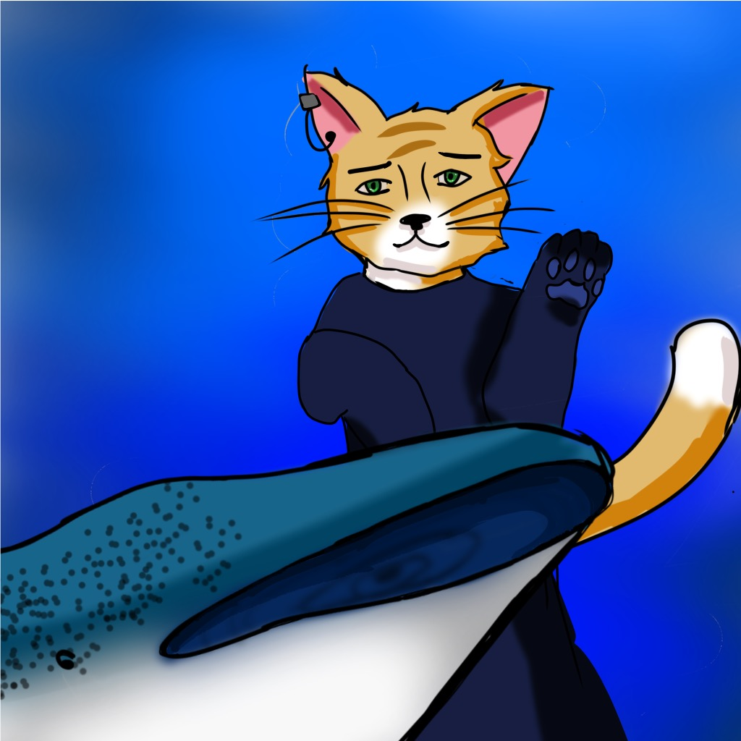

At the beginning of the second week, Zack continued looking for the missing albino manta ray. He was determined and persistent. He didn’t want to give up. This adventure was going to be nothing like the instantly rewarding video games he had been playing for years.

Zack had a feeling he’d find something new if he booked with a different tour company. So he followed his intuition and booked with a company called the Ocean’s Breeze. Zack was excited as he headed out to sea on the new boat. As soon as he entered the water in his dive gear, he spotted a magnificent graceful whale shark. The whale shark started swimming toward Zack as if he had seen Zack before, as if Zack was his long-lost friend. Unfortunately, the feeling was not mutual. Zack quivered with fear and knew he must stay calm. Coming closer, the whale shark reached Zack, but then quickly disappeared into the deep blue water.

Zack’s mind said, “Swim frantically away.” However, his heart said, “Be brave, Zack, and follow the whale shark!”

Page 5

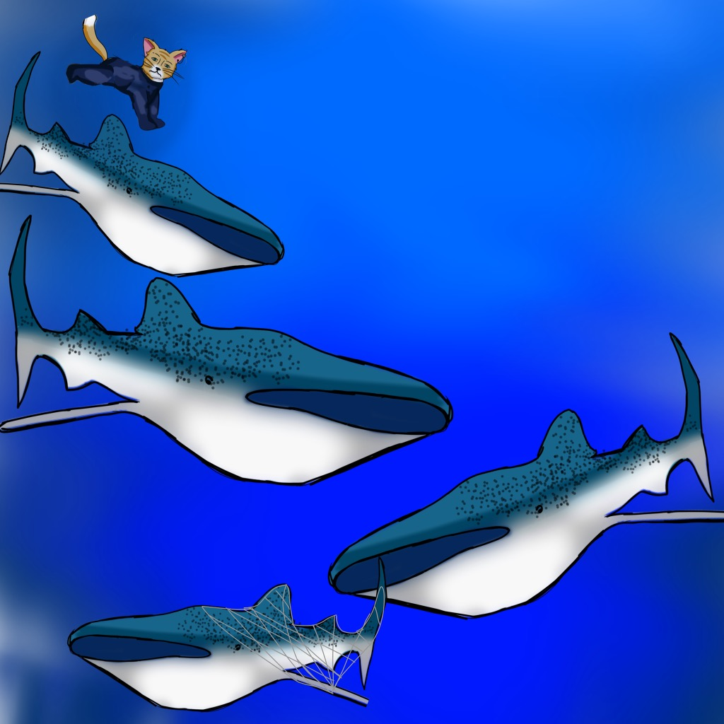

He swam deeper and deeper. Zack felt safe now and intuitively realized something was wrong. The whale shark was trying to get his help. Zack couldn’t hold his breath for that long, so he swam to the surface to get some air. After a few breaths, Zack dove straight back down into the deep sea to follow the whale shark, again. He was amazed when he saw a group of whale sharks and figured they were her family. Zack was elated to meet the family of whale sharks. The hunch he had earlier about the whale shark being in trouble was right, a baby shark was engulfed by a big net! Zack zipped up to the surface to catch is breath one more time. Then he dove back down toward the baby shark and gently untangled the net. In no time, the baby whale shark was free. Zack felt very proud of himself for helping an animal in dire need.

Page 6

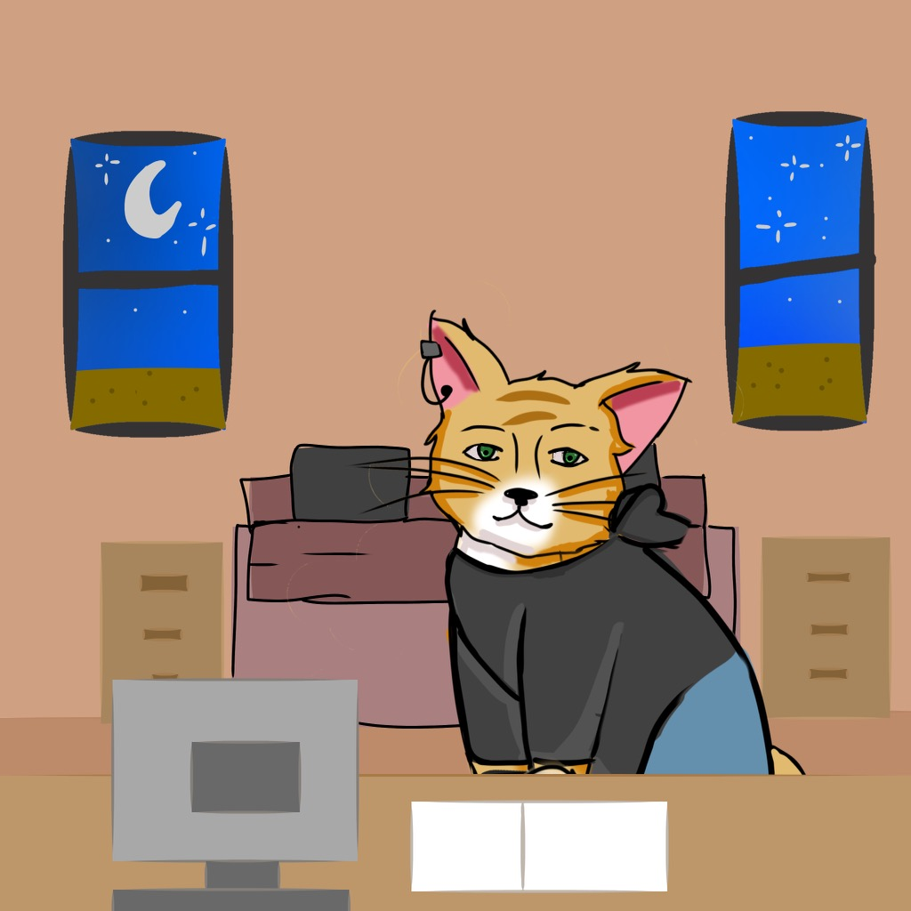

After the baby shark rescue, Zack booked himself a cabin near the ocean so he could hear the calming waves of the sea. He was falling in love with nature more and more.

Still determined to find the albino manta ray, Zack did some research. He learned that they live on the south side of the Big Island of Hawai’i. He also learned that they like to eat plankton. Plankton are tiny organisms found in water that are unable to propel themselves against a current. They are so small they are only seen if you put a light beam in the water at night.

Page 7

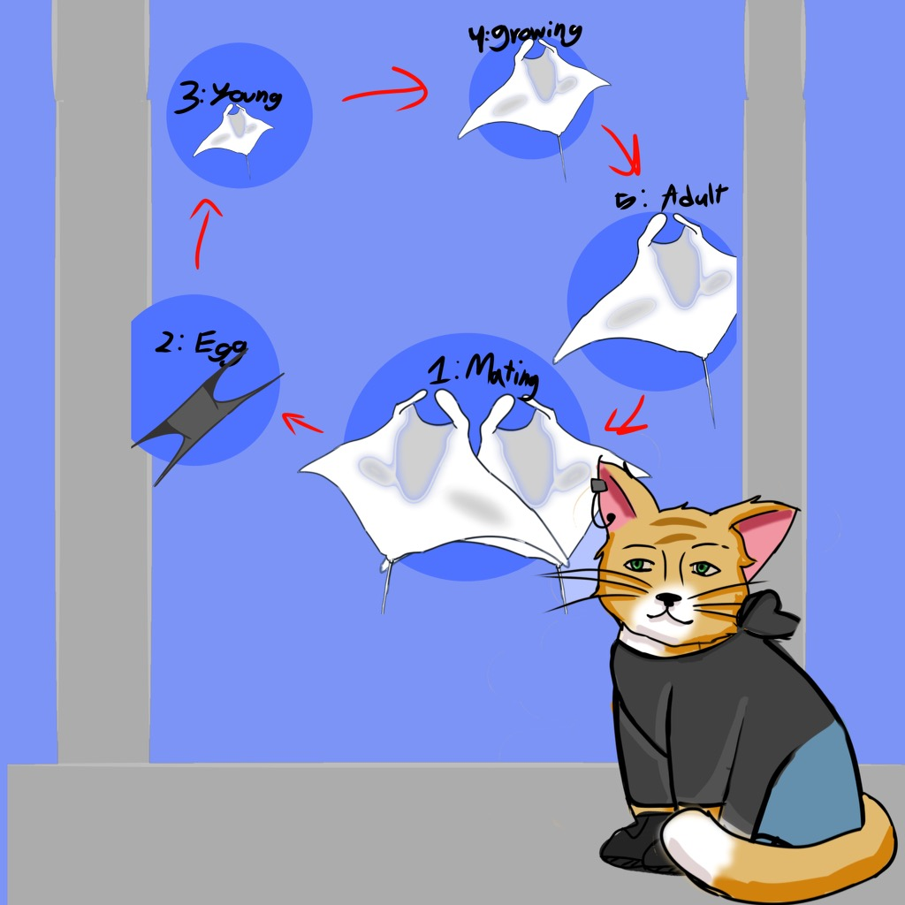

The next day, Zack went to a museum that exhibited sea life. He was inspired to learn more about the sea. He also wanted to see more of the sea! He was curious to find a display about manta rays. The museum had many artifacts and hands-on learning centers. There were also plaques (posted signs) that showed the manta rays' life cycle and environment. While Zack was roaming the halls, he came upon a display that showed a big albino manta ray. He read the sign next to the 3-d model. It said, “These albino mantas are extremely rare because albinism in marine mammals presents several life-threatening changes.” Oddly, the rest of the plaque was blank. Confused, Zack wondered why there were not many facts about the albino mantas. He asked some of the marine biologists, “Why don't you have more information about the albino manta ray?” They had no answers. So Zack went back to his cabin and did more research on his computer, but found nothing more. His curiosity grew.

Page 8

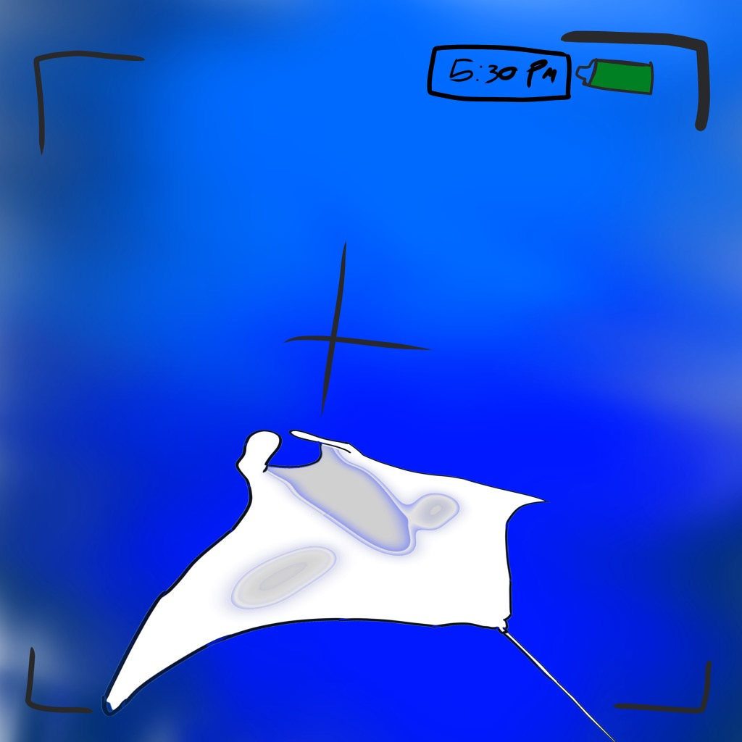

Desperate to find the albino manta ray, Zack hired a third tour company called Hawaiian Coastline Adventure, which specialized in seeing the manta rays at night. When Zack got to the destination to go on the night tour, he met a girl named Zia. She was there to greet people for the manta ray tour. Zia explained the Do’s and Don'ts of the tour. The captain of the boat was named BZ Benda. Captain BZ Benda was kind and carefully explained what the voyagers were to do on this nighttime adventure.

He told the other cats aboard, “You will be hanging onto a surfboard with lights and you will be floating with ankle attachments. An ankle attachment helps you not kick the manta rays. The light beams attract the plankton on which the mantas feed with their toothless mouths. Mantas are harmless to humans even if a swimmer is gently touched.”

As soon as Zack got in the water, he saw two big manta rays and recognized their belly markings. It was Lani-ray and Big Bertha-ray! He was shocked to see them, again. Zack was enjoying the entertaining show with the manta rays, but soon after, low and behold, what did he see? A big albino manta ray swimming by! He quickly grabbed his camera and took a photo of its belly so he could enter it into the contest. Zack was amazed at how big the albino manta ray looked. It had a twelve-foot wingspan!

Pg 9

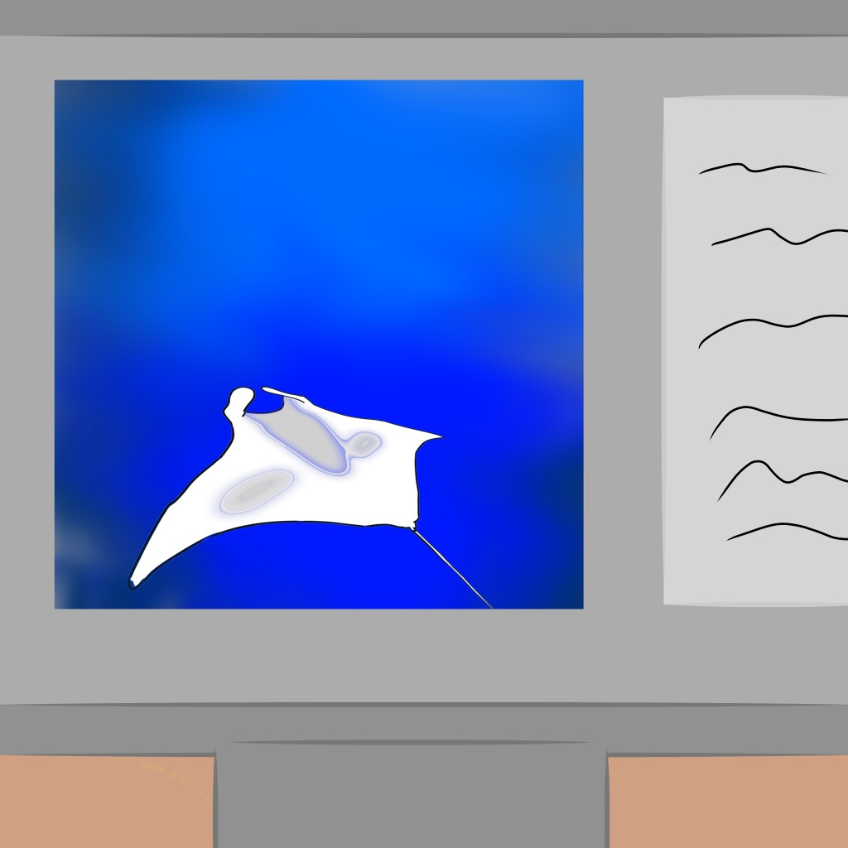

Page 9

As soon as Zack got back to the cabin he submitted the photo to enter the competition.

The next morning Zack got a phone call from the committee chairperson. She announced, “Hello Zack, you are the first person to take a photo of the missing albino manta ray. In return, you will receive one million dollars for finding the one and only albino manta ray, in the world. We have put the one million dollars in your bank account. We also want to thank you for helping us discover the one and only albino manta ray!”

Page 10

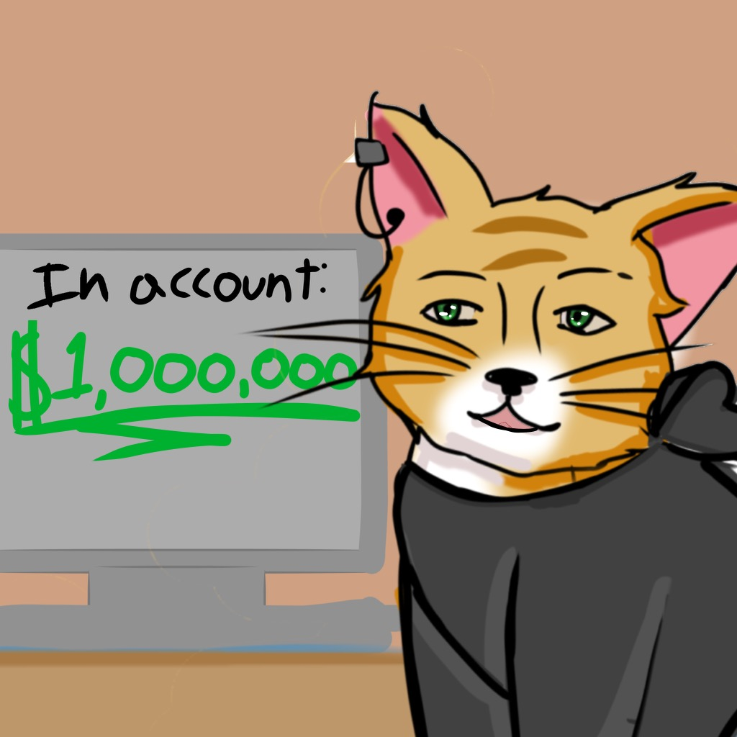

Absolutely shocked, Zack wanted to check the bank to see if they actually put the money in his account. It was there! He was thrilled! Zack started jumping up and down with excitement. He went back to his cabin to decide what to do with his money.

Going online, Zack found the local marine rescue center and hospital. He noticed how dilapidated it was so he immediately went to their donation website. Zack completed all the paperwork and donated $700,000 to the marine hospital. He soon had a call from the marine hospital saying that they greatly appreciated the 700,000 dollar donation. Zack continued to help marine life with the money he received. The rest of the contest money went to open up his very own marine hospital on the Big Island of Hawai’i. He named it, Helping The Animals of the Kai.*

**Moral: Spending more time in nature and limiting your screen time makes you healthier and happier.**

Kai - Hawaiian for “ocean”

Parent Teaching Tips

Phonics: The sound for z is a sound students can hold for a long time. It tickles your tongue.

Make the sound of a bumblebee - this will help practice the sound of Z.

Story Word examples:

Zack

Lazy

Memorize

breeze

Recognize

Amaized

Prize

Spelling Rules:

Rule:

**Z, NEVER S,** spells /z/ at the beginning of a base word (*zoo, zero)*

S makes the “Z” sound. For example: is, was, scissors,

Homophones:

Pg 7 - “See more of the Sea”

Parts of Speech:

Intonation - words that express feelings

Zapped

Zinged

Latin and Greek Roots:

Zo - Greek: Animal

6 Sentence starters:

(Numbers in brackets)

The numbers before the sentences all signify different parts of speech to start the sentences. This gives variety to our sentence structure. IEW curriculum.

1. Start a sentence with a noun.
2. Start sentences with a preposition.
3. Start a sentence with an -ly adverb.
4. Start a sentence with a verb ending with “-ing.”
5. Start with a transition word [www.Asia](http://www.asia) (when, while, where, as, since, if, although)
6. This sentence contains only 2-5 words, a very short sentence. (v.s.s.)